CAN/AM CON
’16
APRIL 23, 2016
Plattsburgh, NY
Theme: Viet Nam - the Early Years (’65-’70)

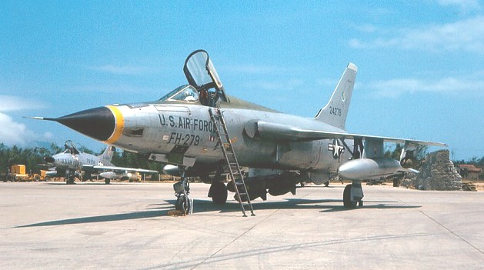

PRESENTED BY:
IPMS CHAMPLAIN VALLEY
&
MOUNT MANSFIELD MODELERS

Visit www.ipmscv.com for more contest information
Location: Admission:
Holiday Inn Adults: $10.00 First Five Models
412 Rt. 3 Adults: $2.00 Each Additional Model
Plattsburgh, NY Juniors: $5.00 First Five Models
9:00 am – 5:00 pm Juniors: $1.00 Each Additional Model

General Admission $1.00, Children Under 12 Free
For Further information and vendor table info
Please Contact:
Frank Baehre Tel: (518) 561-4265
216 Champlain Drive, Plattsburgh, NY 12901 USA
email: frankandsandyb@verizon.net


