South Carolina
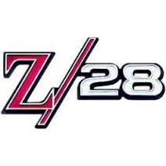

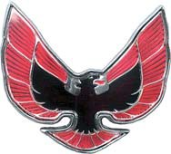

Modelers Association
19th Annual Fall Model Contest & Show
Oct. 21, 2017
Cokesbury United Methodist Church, Gym
4990 Dorchester Rd., North Charleston, SC
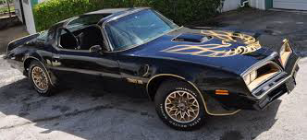

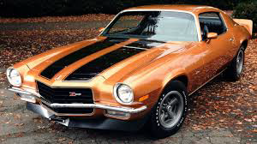

Automotive Theme: “50th Anniversary of the Camaro & Firebird” (any Camaro or Firebird Subject)

Non-Automotive: “Rated X” Experimental Aircraft
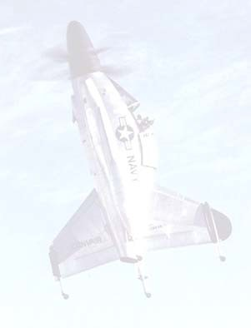
(any aircraft with an X designation)
(IPMS Coastal Carolina Modelers will judge all non-automotive classes)

Lathe Raffle

A new Central Machine, 7x10 lathe with tool box Cutting Tools, Measuring Tools and some Aluminum round stock in different sizes to be raffled off in support of the 2018 SCMA January contest. The Spartanburg Chapter will be selling raffle tickets for $5.00 each or 6 for $25.00.

SCHEDULE Registration: 8:30 – 11:30am Judging: Noon – 1:00pm Awards Presentation: 2:00pm
$5.00 for the first model ($1.00 each additional model) No charge for “Display Only” Free General Admission
Vendor Tables: $20.00 each (PREPAID)

Vendor info:
Ron Minton (843) 637‐9099 imcminton@gmail.com

Modelers info:
Don Franklin (843) 884‐4609 cell (843) 870‐2002 cherylfranklin@sprintmail.com

