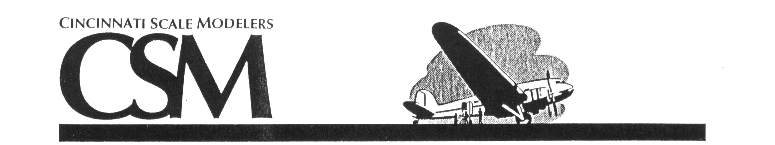

2018 Contest and Swap Meet - All Modelers Welcome
Door Prize a $75.00 Vendor Merchandise Certificate

Cincinnati’s Famous Humongous Raffle

October 20st, 2018 Registration. 9:00 AM – 12:30 PM
9:00 AM – 4:30 PM Judging……..12:30 PM – 3:30 PM

Scarlet Oaks Vocational School Awards………………………….3:30 PM

Sharonville, Ohio Show Ending at………………4:30 PM

E. KEMPER RD

MOSTELLER RD

READING RD
PARKING
I-275
EXIT 46

I-75
EXIT
16

I-275
EXIT 44

N
W
E
S
I-71
EXIT 17

DEPOT DR
LEBANON RD
From I-71 Exit 17
Take I-275 West to Exit 46
Turn left (South) on Lebanon Rd
Turn right (West) on E. Kemper Rd
Turn right (North) on Depot Dr
at the GREAT OAKS sign
I-275
SHOW
From I-75 Exit 16
Take I-275 East to Exit 44
Turn left (South) on Mosteller Rd
Turn left (East) on E. Kemper Rd
Turn left (North) on Depot Dr
at the GREAT OAKS sign

Contest Entry Fees Contest and Vendor Contact

Adult: $5.00 for 1-3 entries Don Flynn
$1.00 for each additional entry 60 Williamsburg Ln Sharonville, OH 45241
Juniors: $3.00 unlimited entries Email: donaldflynn@fuse.net
General Admission - $5.00 513-777-6618 (12pm- 2 pm, after 2pm
12 and under admitted free ☺ Please leave message Monday-Friday)
Vendor tables 6’ $35.00 per table http://www.cincyipms.com

