MODEL MANIA TUCSON PRESENTS

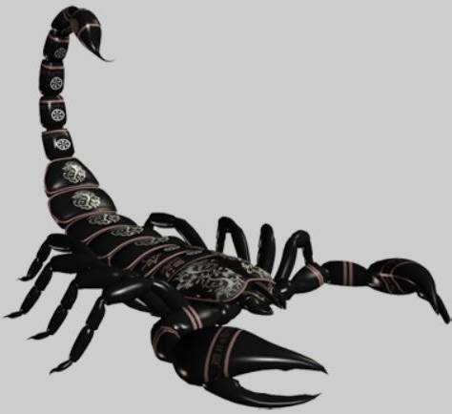 SCORPFEST vi 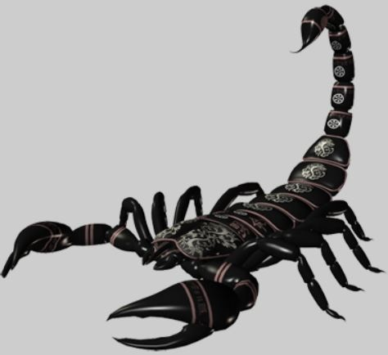

PLASTIC MODEL SWAP MEET & MODEL CONTEST
SATURDAY JANUARY 12, 2019
9:00 am to 3:00 pm

Located at:
Tucson FOP Lodge #1
3445 N. Dodge Blvd
Tucson, Arizona

ADMISSION $2.00
Make-N-Take!
GOLD, SILVER, BRONZE
Contest Awards!
RAFFLE PRIZES!!!!

CONTEST SPONSORED BY SONORAN DESERT MODEL BUILDERS
Lots of Different Contest categories
Best of Show! & People’s Choice Award!
$5 entry fee for up to 5 models. No fee for junior entries.
5 model entry limit for everyone - NO EXCEPTIONS!
For more information on contest contact DAVE: brightstalion@yahoo.com

VENDORS
Vendor tables available by advance reservation:
8’ table for $35.00 until January 1st ($40.00 after January 1st until show)
Table fees must be paid to confirm table reservations
Tables sell out quickly so reserve your tables early!
Vendor set-up: January 12, 2019 7:00 am – 9:00 am
For more information on vendor tables contact DEREK: 4nagato1@gmail.com

 MODEL MANIA TUCSON

