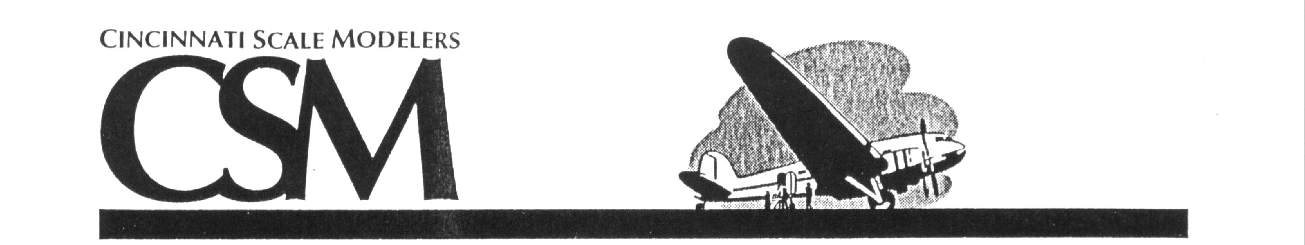

2021 Contest and Swap Meet - All Modelers Welcome
Door Prize a $75.00 Vendor Merchandise Certificate

Cincinnati’s Famous Humongous Raffle

October 30th, 2021 Registration. 9:00 AM – 12:30 PM
9:00 AM – 4:30 PM Judging….…...12:30 PM – 3:30 PM

Tri-State Warbird Museum Awards……………………….…3:30 PM

Amelia, Ohio Show Ending at………………4:30 PM
The Tri-State Warbird Museum is conveniently located on the eastern side of Cincinnati, just minutes off Interstate 275 and State Route 32, located at the end of a set of streets named after heroic aviation and space pioneers Neil Armstrong, John Glenn, and Frank Borman. To reach the Museum, take Interstate 275 to State Route 32 East (Exit 63B). Follow Route 32 for 3.0 miles to the third traffic light and turn right onto Old State Route 74. Follow Old SR 74 for 1.1 miles and turn right onto Armstrong Blvd. Make the next left onto Glenn Parkway. Finally, turn right onto Borman Drive. The Museum is located at the end of Borman Drive, next to the Clermont County Airport.
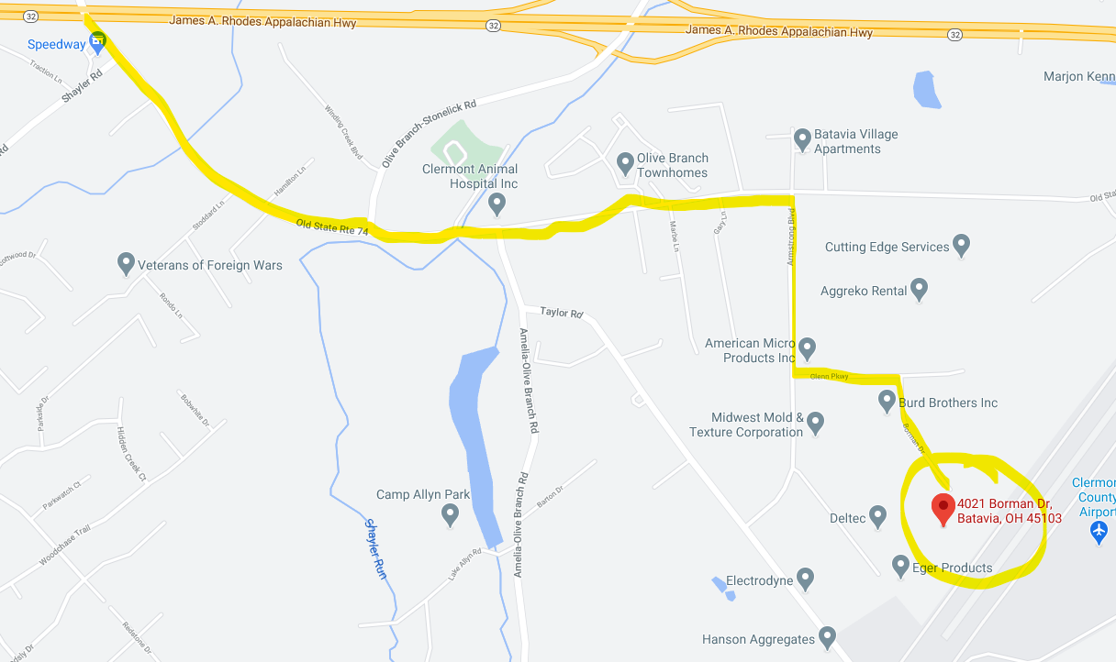

Contest and Vendor Contact
Don Flynn
60 Williamsburg Ln Sharonville, OH 45241
Email: donaldflynn@fuse.net
513-777-6618 (11am- 2 pm) (Please leave message Monday-Friday)
Check our website for more show details www.cincyipms.com

