Contest Qualifications ( Continued )

Wargaming Pieces A figure will be considered a Wargaming piece if it is mounted solely on a square or round ‘slotta’ type base – even if that base is decorated. A wargaming piece mounted to a new base or with its cast-on base wholly obscured within an all-new base will be considered a figure.

Markings will determine the class in which the model is entered. For example, an aircraft with military markings will go into a military aircraft category. If that same type aircraft has civil markings, it will fall into the appropriate civil aircraft category.

Collections defined by BRSM, has a different interpretation than that customarily used by IPMS. For the purpose of this competition, a collection can be any five or more models, which are related by any specific link or theme. Note that the theme must be specific in nature (i.e. five German aircraft is too loose of a theme, whereas five German Reich Defense aircraft would qualify). Any questions regarding theme should be directed to the head judge.

Missiles All missiles in flight attitude or on landing gear will be entered in the appropriate aircraft category. Missiles which are used in space research that originated as military vehicles will be placed in the space category.

No Sweep Rule An individual may only place 2 out of 3 places within any one category unless that entrant is the only entrant in that category.

Proxy Entries Models built by and entered in the name of a person other than the person actually completing the Entry Form MUST be accompanied by a valid telephone number of the person who constructed the model.

Contest Judging
Craftsmanship – flash and mold mark removal, glue work, seams, etc.

Finishing – paint and decal application, correctness of weathering, shadowing and other detailing.

Weathering – correctness and consistency of weathering, if applied.

Judging will be done by a committee of an odd number of modelers. Modelers will be selected as judges based on their known fairness, knowledge, and modeling competence. Modelers will not be allowed to judge categories in which they are entered. The Head Judge has the right to split or combine categories as needed.

All decisions made by the Judges are final.

Directions to Modelfest
This year’s Contest will be held at the LSU AgCenter 4H Minifarm, on the LSU Campus. It is located behind (to the South of) the Parker Colliseum.

From I-10 Westbound:
Exit at Acadian Thruway, turning left under the Interstate. Stay in the left lane. Acadian will change names to become Stanford / LSU Avenue. Proceed on Stanford to Highland Rd. and turn right. The venue is just off Highland Rd. on Ag Center Dr., to your right.

From I-10 Eastbound:
While on the Mississippi River bridge, stay in they right-most lane. Exit at Nicholson / LSU 155A. Merge left onto Highland Rd. Travel on Highland approximately 2.5 miles to AgCenter Drive, on your left

Once You’re Here:
In all cases, you may drive up Ag Center Dr. to the venue to drop off your models, but you must park in the Parker Coliseum parking lot for the remainder of the day.

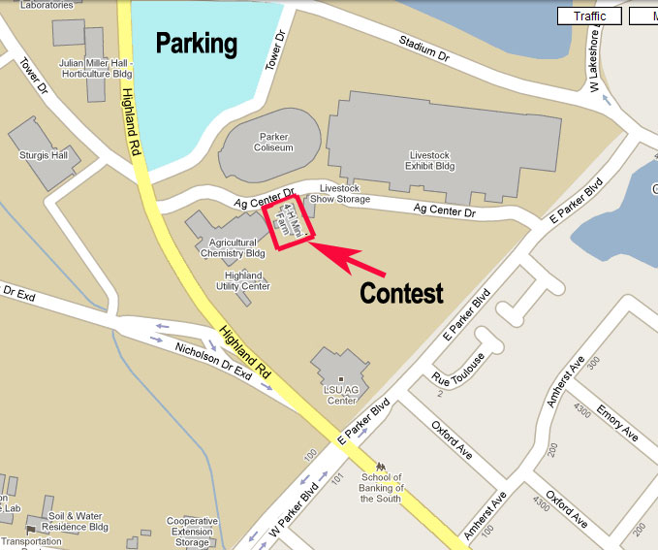BRSM Club Meetings

When: Second and last Thursday of each month at 7:00 PM
Where: Jones Creek Library

No matter what you build or how long you’ve been building kits, everyone is welcome to join us at our club meetings or the show.

The annual Modelfest shows began in 1985 and have been going strong ever since.

For More Information, Please Call

Jimmy Robillard 225-938-3072 jrbr52@cs.com



IPMS Baton Rouge
Cajun

ModelFest 36

Plastic Scale Model Show and Expo

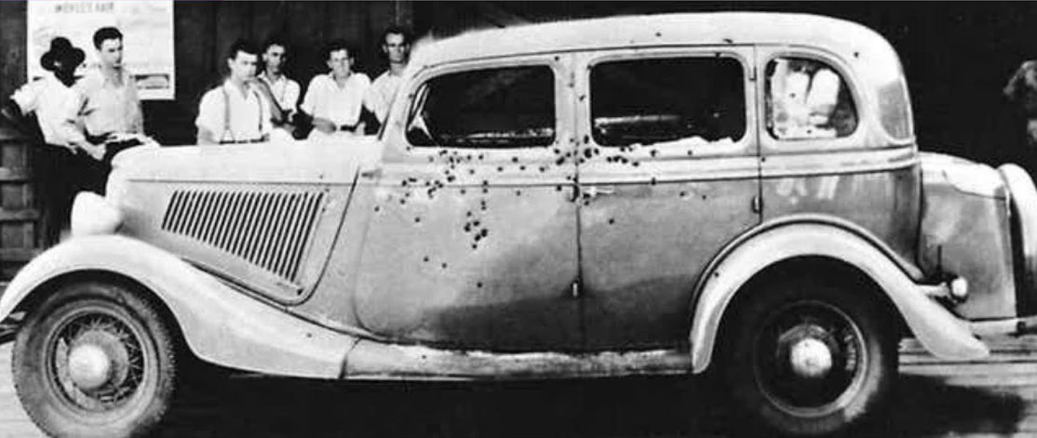
This Year’s Theme:
“Damaged Goods”
Any model subject that depicts physical damage
Nov. 2, 2024
LSU Ag Center 4H Minifarm Building

Raffle  Kid’s Make-and-Take  Lunch & Snacks For Sale On-Site
Baton Rouge Scale Modelers

IPMS / USA , Region Six, Chartered Club
Schedule:

Vendor Area: 8:30 am 3:00 pm

Registration: 8:45 am 12:00 pm

Judging: 1:00 pm 3:00 pm

Award Presentation: 3:00 pm 4:30 pm

Special Awards
Best Themed Kit Best in Show
Best Aircraft Best Ship
Best Armor Best Figure
Best Automotive

Categories (Will expand or split as need arises)

100 Young Modelers
101 Preteen (ages 12 and younger)
102 Teen (ages 13 to 18)

200 Aircraft
201 1/72 or Smaller: Prop
202 1/72 or Smaller: Jet
203 1/48 Prop
204 1/48 Jet
205 1/32 or Larger
206 Civilian
207 Rotary Wing
208 Scratch Build and Conversions**
209 Basic Kit Build**
210 Miscellaneous Aircraft (does not fit in categories above)

300 Military Vehicles
301 1/72 and Smaller
302 1/48
303 1/16 or Larger
304 1/35 Tracked Vehicles - Open Top
305 1/35 Tracked Vehicles – Closed Top
306 1/35 Wheeled Vehicles - Armored
307 1/35 Wheeled Vehicles – Soft Skinned
308 1/35 Artillery, Missiles, Towed (no SPGs)
309 Scratch Build and Conversions
310 Basic Kit Build
311 Miscellaneous Military Vehicles (does not fit categories above)

400 Automotive
401 Large Scale Vehicles: 1/16 or Larger
402 Small Scale Vehicles: 1/32 and Smaller
403 Street Stock AE (Any Era)
404 Street Rods/ Machines AE Modified
405 Custom – Includes Exotic and Low Riders
406 Competition – Closed Wheel
407 Competition - Open Wheel
408 Commercial and Off-Road Vehicles
409 Motorcycles
410 Basic Kit Build
411 Miscellaneous Automobile (does not fit categories above)

500 Ships
501 Large Scale Surface Vessels (1/350 or Larger)
502 Small Scale Surface Vessels (1/349 or Smaller)
503 Submarines
504 Sail or Oar Powered Vessels
505 Miscellaneous Vessels (does not fit categories above)

600 Space and Science Fiction
601 Real Space Vehicles
602 Sci-Fi and Fantasy Vehicles - Flying
603 Sci-Fi and Fantasy Vehicles – Ground and Water
604 Mecha
605 Gundam/ Gunpla
606 Miscellaneous Space and Sci-Fi (does not fit categories above)

700 Figures
701 Small Scale Fantasy Figures (54mm or smaller)
702 Large Scale Fantasy Figures (55mm or larger)
703 Small Scale Real Figures (54mm or smaller)
704 Large Scale Real Figures (55mm or larger)
705 Busts

800 Dioramas
801 Diorama (more than one vehicle or 5 or more figures)
802 Vignettes (one vehicle and 4 or less figures)

900 Miscellaneous
901 Collections and Triple Play
902 Wargaming Collections or Sets
903 Anything not covered by a category above (animals, dinos, buildings, furniture, weapons, tools, etc.)

Schedule of Fees Adult Juniors
1st Model Entry fee $ 10.00 Free
Next 10 Additional Entries $ 2.00 ea. Free
More than 11 Additional Entries $1.00 ea.
Non-participant Entry $ 2.00 Free
Raffle Tickets $ 1.00 or 6 for $ 5.00

Vendor Tables $ 15.00
Trophy Sponsorships $ 25.00

Contest Rules
Models that have won 1st, 2nd ,3rd or any special award at any previous IPMS Regional or National contest are not eligible for the current contest. These models are welcome in the display area only.
Any modeler is eligible to enter any number of models at Modelfest. Models may be entered by “proxy”. All entries must be the sole work of the individual whose name is on the entry form. Exception: If a group category is listed. No one will be allowed to enter the contest area prior to registering their model(s). Unattended children will not be allowed in the model display areas.

“Politicking” for any model, whether pro or con will not be tolerated. Any abuse of this rule will result in the disqualification of the offender’s model and/or the ejection of the offender from the contest.

The contest Committee will determine the category of entry. The Contest director will be consulted for interpretation should a question of category placement arise. Judges will reserve the right to move a model if they feel it was entered into the wrong category. Every effort will be made to inform the contestant of the decision made, and be discussed with the judges.

The contest director or head judge may exclude from public display, any entries that are deemed offensive to generally acknowledged standards of taste or acceptability.

Test shots or pre-production examples of kits not yet commercially available may not be entered unless the entrant is the designer of the kit.

Contest Qualifications
Scratchbuilt refers to models built primarily from parts or materials unrelated to their original identity. Parts from other kits may be incorporated where their original identity has been changed except for minor parts such as wheels, guns, etc. Documentation shall be required with each entry outlining materials used. Conversions and scratchbuilts will be classed together unless numeric interest compels otherwise.

Bases / Dioramas Bases are allowed in all categories and will not be considered in the judging, except in the Diorama classes. A base may simulate the natural surface on which the subject would be found; however, nothing other than that surface may be used. Aircraft and vehicles may rest on simulated ground or paving, and aircraft which need beaching gear or dollies may be so equipped. Ships may be displayed in water (no dry-docks). The base must not be the predominant feature or the entry must be of a size proportional to the model being displayed. The contest chairman and judges reserve the right to exclude oversize bases. The model may include primary crew figures. The addition of any other figures or equipment outside, or not attached to the model (e.g., buildings, foliage, support equipment, etc.) will make the model a diorama, Dioramas are judged not only on the technical merit of their construction, but also on the strength of the theme or the story they present. Therefore, if two dioramas are technically equal, the one having the stronger theme or story will win.

Vignettes v. Dioramas A grouping of five or fewer figures and their equipment (including non-motorized vehicles) displayed in an appropriate setting will be considered a vignette. If any included vehicles are motorized, or if more than five figures are included, the entry will be considered a diorama.

Conversions Entries must contain significant structural changes to the basic kit involving extensive changes in contour or configuration. This is defined as a change to more than 25% of the original model. Commercially available conversion kits may be used. Entrants should be prepared to furnish a list of parts and material used upon the request of the judges.

Figures may be made of metal or plastic. Metal miniatures may also be included in Dioramas where they do not comprise the primary model. The inclusion of accessories provided in the figure kit will not cause the figure to be classed as a Diorama

