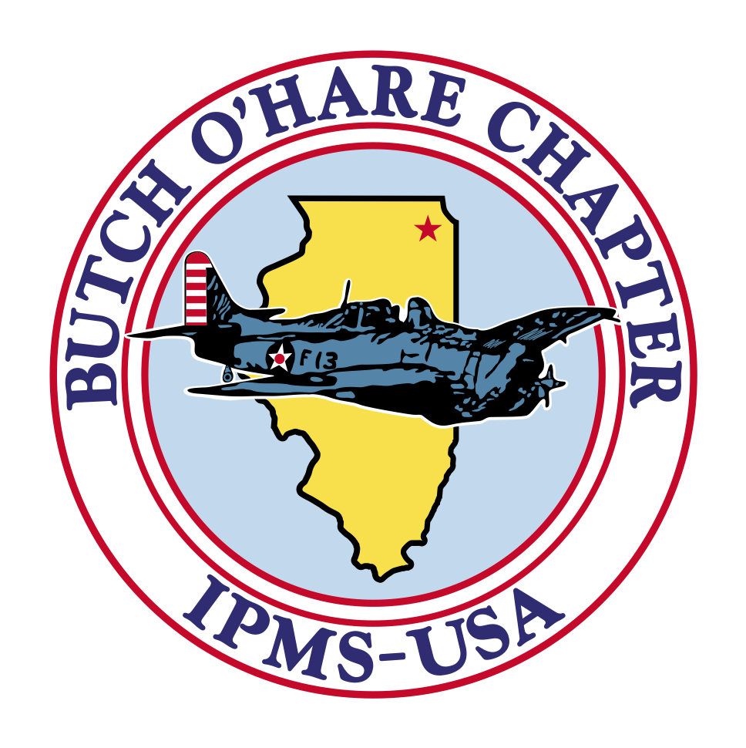
NEW LOCATION

TIMETABLE:

7:00 AM --- VENDORS SETUP

9:00 AM --- DOORS OPEN TO THE PUBLIC

11:00 AM -- 1ST RAFFLE

NOON ----- REGISTRATION CLOSES

4:00 PM -- AWARDS ANNOUNCED

5:00 PM -- END OF CONTEST FOR 2018

CONTEST ENTRY FEES: $10 ADULT (over 17 YRS old) FIRST 4 MODELS, $4 FOR EACH ADDITIONAL MODEL

37TH ANNUAL– IPMS BUTCH O’HARE CHAPTER
oooo

Featuring:

50+ Loaded

VENDOR TABLES!!
SATURDAY – NOVEMBER 9, 2019
Holiday Inn, Itasca
SCALE MODELERS – BRING OUT YOUR BEST!
COMPETE FOR SPECIAL AWARDS WITH MODELERS FROM
CHICAGOLAND AND THE ENTIRE CENTRAL REGION
FACT: ONE OF THE BEST TRADER ROOMS AT A LOCAL SHOW IN THE MIDWEST!

WALK THRU
(SPECTATOR FEES)
$5 ADULT (OVER 17 YRS OLD)
$1 JUNIOR (OVER 12 to 17 YRS)
$ FREE FOR KIDS UNDER 12 YRS
EARLY BIRD ENTRANCE TO THE VENDORS ROOM FOR $10
(8 AM START TIME)
RAFFLE TICKETS DRAWN THROUGHOUT THE DAY
$1 each/6 for $5
Judged by “CHICAGO RULES”
UNLIMITED CLASS AWARDS IN GOLD, SILVER & BRONZE MEDALLIONS! RECOGNIZING YOUR MODELING SKILLS, PLUS: SPECIAL AWARDS For DISTINGUISHED MODELING EXCELLENCE:
Best in Show – Best Aircraft – Best Armor – Best Nautical – Best Auto – Best Figure – Best Sci-Fi – Fantasy/Comic – Best Diorama – Best Junior and Many More!!!! New Categories for Sci- Fi, Fantasy, Gaming, and Real Space
Three new seminars to attend this year!
Check our web site for more information!

Event INFORMATION:
REGISTRATION FORMS & INTEL
Go to Our Website:
www.butchoharemodelers.com
Or contact our chapter contact
Frank Ciccarella
FCiccarell@aol.com
VENDORS TABLE RESERVATIONS AND INTEL:
Hector Colon
630-809-9072

hdcolon@yahoo.com
860 W. Irving Park Road, Itasca, IL 60143

OPEN MODEL CONTEST

