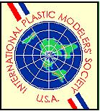
SATURDAY APRIL 20, 2024
QUALITY INN PERRYSBURG
10621 FREMONT PIKE
PERRYSBURG, OHIO 43551
Take Interstate 75 to exit 193 (Fremont Pike/US 20/US 23 South), just south of I-80/90 exit 64. At exit 193 go East on Fremont Pike. The Quality Inn will be on your right.
SHOW SCHEDULE:
7:00am...........................................VENDORS UNLOAD & SET UP
9:00am... DOORS OPEN TO THE PUBLIC, REGISTRATION OPENS
12:00pm..... REGISTRATION CLOSES, CONTEST JUDGING BEGINS
4:00pm......................... (approximate) AWARDS PRESENTATION

54 Contest Categories * 17 Special Awards, including “Putin World Tour” trophy for Best Ukraine War, Battle of the Bulge, Operation Market Garden, & Battle of the Hurtgen Forest Subjects * Raffles * Vendors Room

Contest Entry Fees: $10.00 – First 3 models, $1.00 each additional model
Juniors 12 & under and general public – FREE!

VENDORS: 6-foot tables are $30.00 each.
Contact Rick Geithman: pzkw-6@bex.net

Chairman: Mark McGovern: mcgovernsmodels@gmail.com (419) 206-9135
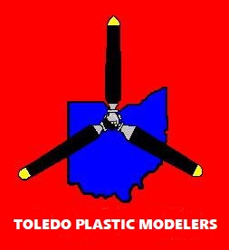
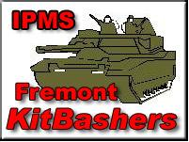
Hosted by IPMS/Fremont KitBashers
and the Toledo Plastic Modelers
Find us on Facebook:
https://www.facebook.com/profile.php?id=61550537183877
Visit our website: https://markathy.wixsite.com/model-con-419

