CALMEX XXXII
PLASTIC MODEL SHOW AND CONTEST
Sunday, January 28, 2018 at Lake Charles Civic Center
900 Lakeshore Dr. Lake Charles, LA. 70602
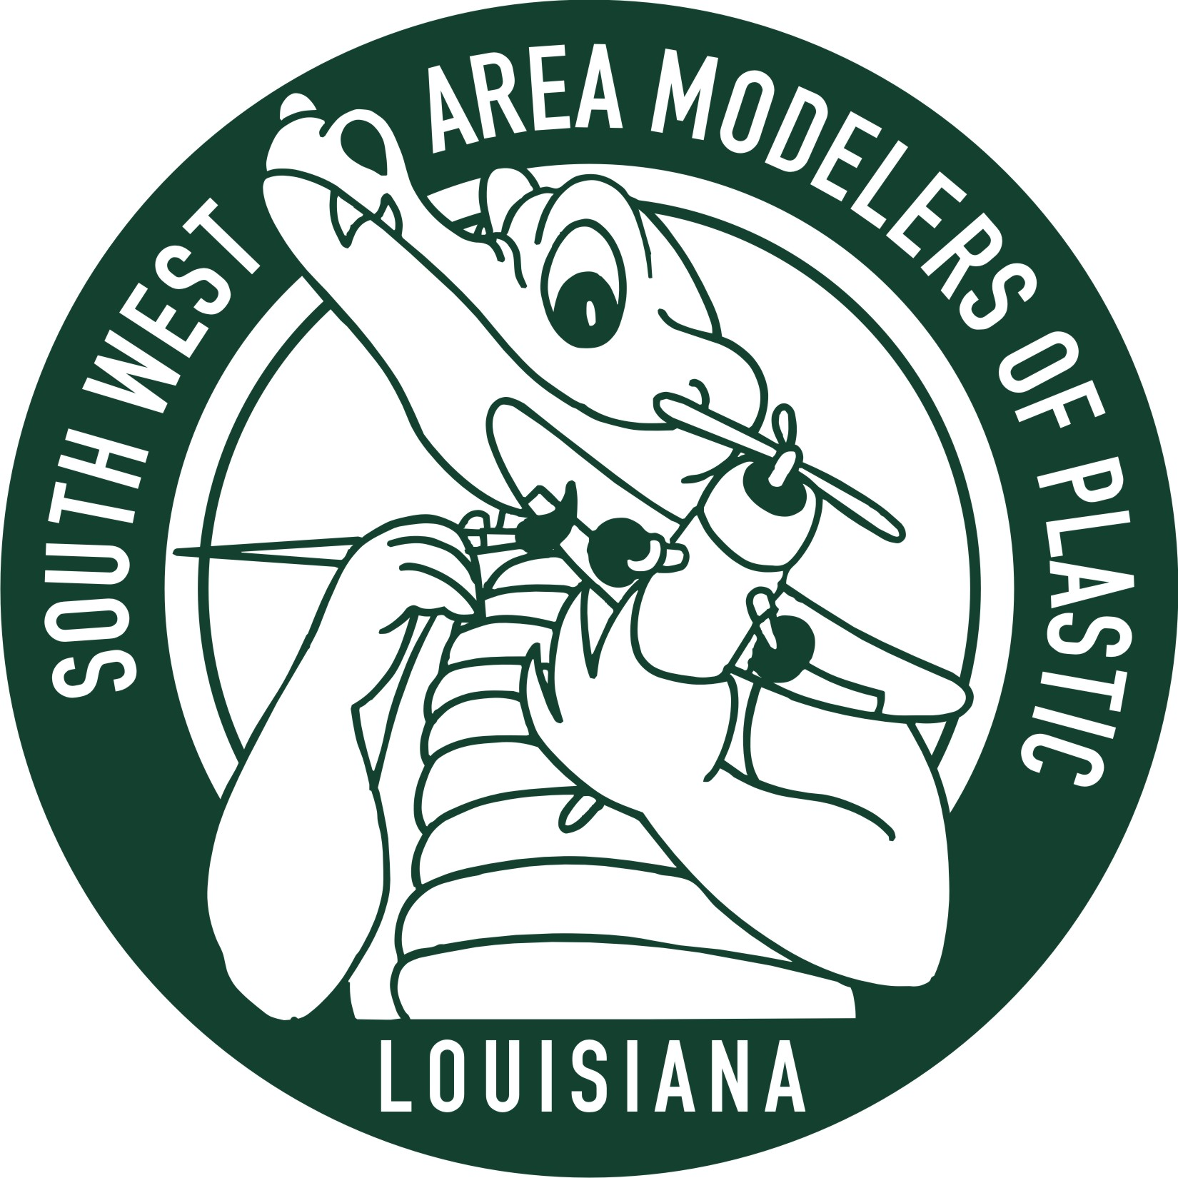
Vendors, Raffle and Food on Site
Southwest Area Modelers of Plastic proudly present our annual contest and show.
IPMS sanction
International plastic modeler’s society
Anyone can enter a model!
Three divisions Adult, Junior, and Pre Teen with over seventy categories

Entry fees for the contest are: Adults $10 for first model. Each additional model is $1.00;
Juniors - (13-17 Yrs old) - $5 for 5 models; - Pre-teen (12 yrs old and under) free.

The vendor area will be open from 8:00 AM. To 5:00 PM

FREE Admission to view models and the vendor area.
Best viewing time is noon to 3:00 PM

Registration is from 9:00 AM. To 12:00 PM. Judging will start at 1:00PM.
Awards presentation will be at 4:00 PM.

For more information on directions and entry forms go to:
www.ipmsswamp.com Check CALMEX for forms

Contact Bob at swampclub@yahoo.com. Put “contest” in the subject line. So I will open it.

