CALMEX XXXIII
PLASTIC MODEL SHOW AND CONTEST
Sunday, January 27, 2019 at Lake Charles Civic Center
900 Lakeshore Dr. Lake Charles, LA. 70602
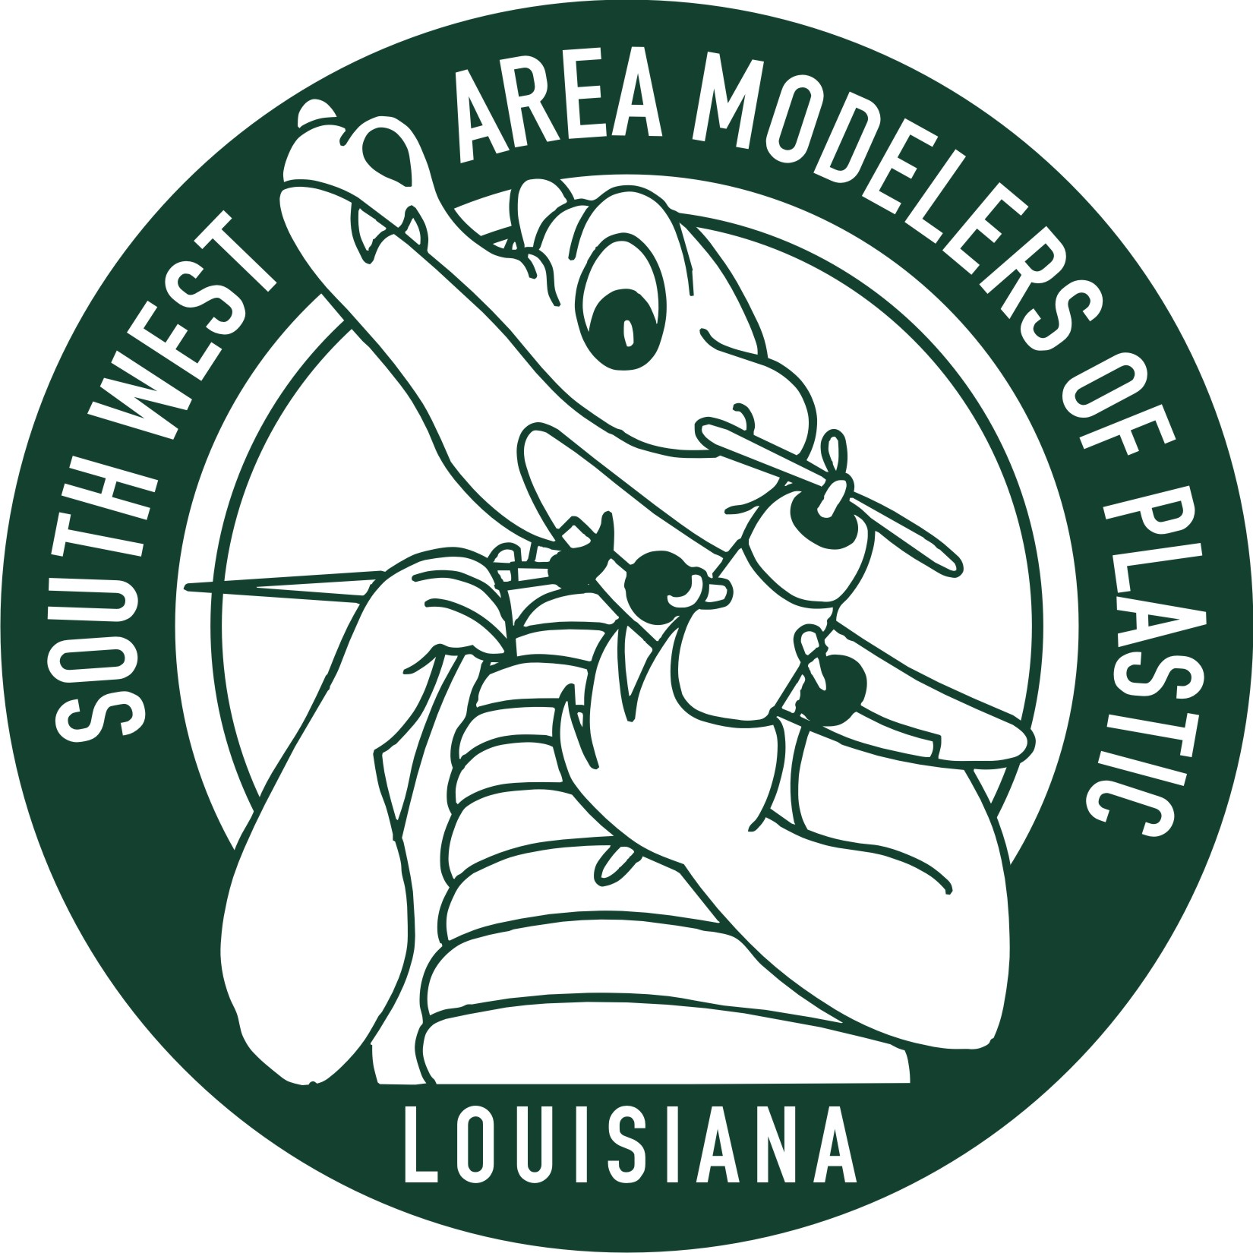
Southwest Area Modelers of Plastic proudly present our annual contest and show.
IPMS sanction
International plastic modeler’s society
Vendors, Raffle and Food on Site
Anyone can enter a model!
Three divisions Adult, Junior, and Pre-Teen with over seventy categories

Entry fees for the contest are: Adults $10.00 for first model. Each additional model is $1.00;
Juniors - (13-17 Years old) - $5.00 for 5 models; - Pre-teen (12 years old and under) free.
For that model you are looking for
The vendor area will be open from 8:00 AM. To 4:00 PM

FREE Admission to view models and the vendor area.
Best viewing time is Noon to 3:00 PM

Registration is from 8:00 AM. To 12:00 PM. Judging will start at 1:00PM.
Awards presentation will be at 4:00 PM.

For more information on directions, categories and entry forms go to:
www.ipmsswamp.com Check under - CALMEX for forms

Contact Bob at swampclub@yahoo.com. Put “contest” in the subject line. So I will open it.

