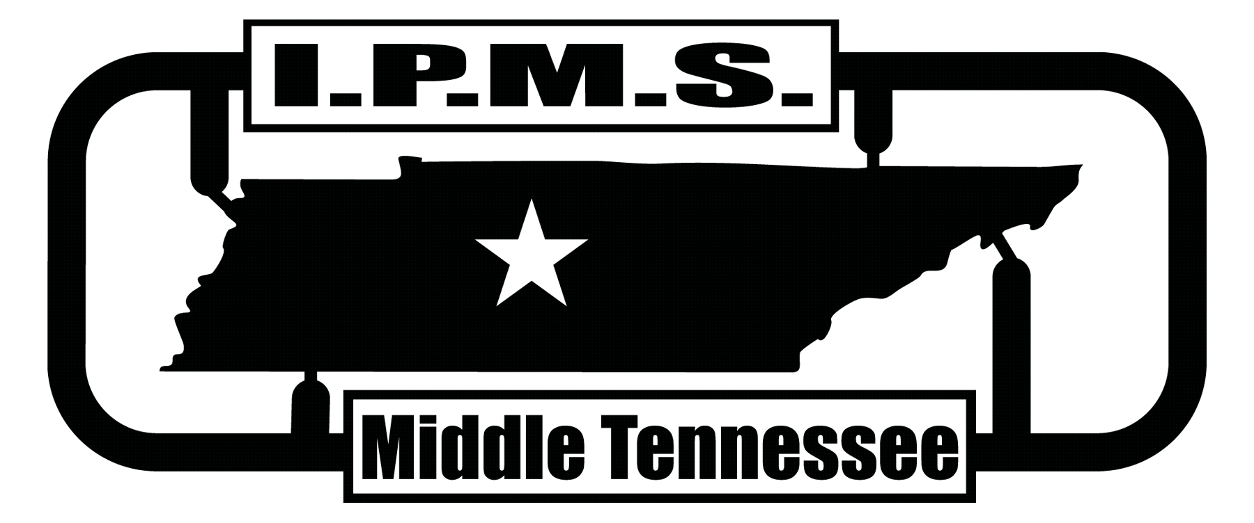

MODEL CONTEST

November 5, 2016 9:00 am - 5:00 pm
Rutherford County Agricultural Center
315 John Rice Boulevard, Murfreesboro, TN 37129
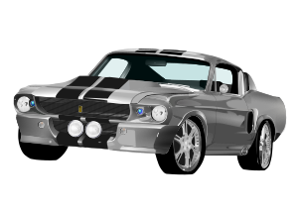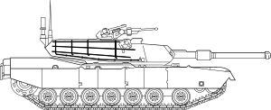

Vendor information:
Alex Robinson 615-828-4139 alexrobinson1226@gmail.com

www.ipmsmiddletennessee.com

