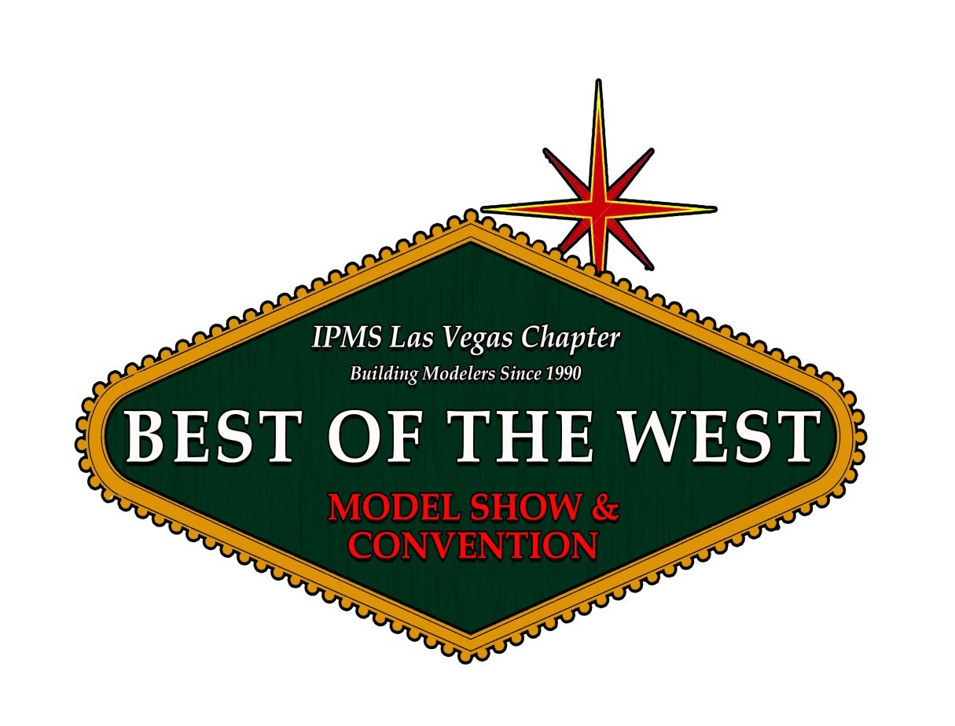

BEST OF THE WEST

CHAPTER 30TH

ANNIVERSARY

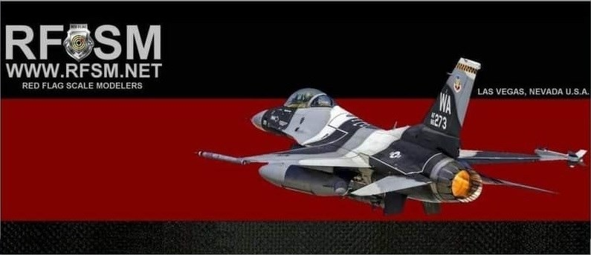

**Saturday May 24th, 2025**

**Orleans Hotel Casino Las Vegas, NV**

**Show Brought to you by IPMS Las Vegas, with help from Red Flag Scale Modelers, Las Vegas Model Car Club, Vegas Armor Modelers Preservation Society, and Gunpla Builders United**

**Tons of Vendor Tables, 49 Contest Categories, IPMS 1,2,3 Judging Criteria**

**Special Judging rules: No Touching Models, No Flashlights, No optical devices and or Mirrors, No Sweeps.**

***Contest & Show Admission (CASH ONLY)* Doors open 9:00 am, Judging noon, awards 3:30 pm, close 5:00**

**Adult Model Entry $15 for the first 2 models, $2 for each additional model. 1 guest per entrant**

**Juniors (under 17) FREE (unlimited entries) Special Awards to be announced at a later date.**

***General Show Admission***

**(All other attendees) $5 each Adult & Family. Children under 12, Active Military & First Responders are FREE FOR MORE INFORMATION: Www.ipmslv.org for contest forms. Or email** [**ipmslv@aol.com**](mailto:ipmslv@aol.com) **Orleans Hotel 702-365-7111. April 25th cutoff date. Room Reservations code IPME25P. Vendors Contact and Show Coordinator Jay Bergeon 702-861-9050 ipmslvraffle@yahoo.com**

**Chapter 30th Anniversary**