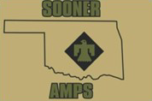 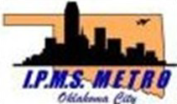 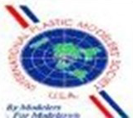

# IPMS METRO OKLAHOMA CITY

**In association with SOONER AMPS Presents**

**OKCMetroCon**

# 2025

# Saturday, June 21st, 2025 9am-4pm

**Council Road Baptist Church**

**Building is named “The Cube” north of main church building**

## 7903 NW 30th Bethany, OK 73008

**Theme**: **“The Silver Screen”**

**Any subject eligible for the theme award must be tied to a specific movie and must have appeared in the movie**

**ALL MODELERS ARE WELCOME**

**Plastic Models of all kinds welcome: Aircraft, Tanks, Ships, Automotive, Figures, SciFi**

Entry Fee is $20 with unlimited entries for IPMS judged categories.

AMPS judged categories are limited to five (5) models

Modelers 16 & under: 1st Model is Free $5.00 for unlimited Junior Entries

OKCMetroeCon 2025 will use 1st, 2nd, 3rd IPMS/USA judging rules for all non-Armor categories.

AMPS Gold, Silver and Bronze medal judging rules for all Armor categories.

## General Admission is FREE

*Donations are welcome*

**For more details on OKCMetroCon 2025 see:** [**www.ipmsmetrookc.com**](http://www.ipmsmetrookc.com/) **https://**[**www.facebook.com/IPMSMETROOKLACITY**](http://www.facebook.com/IPMSMETROOKLACITY)

**VENDOR TABLES AVAILABLE**

Vendor Tables $25 each until May 31, 2025 after that $35 each June 1 thru June 21

Vendor Contact: Brett Ellis

Call or Text: (405)898-9530

E-Mail: bret2393@att.com